

FOR IMMEDIATE RELEASE SHOWROOM: 101 S. Hamilton

Contact: Mary Leigh Howell
ml@maryleighhowell.com
(336) 317-7713

Universal Furniture Introduces the Artfully Collected Emerie
IMAGES: https://www.dropbox.com/scl/fo/8l9v3c9gs1k6qx0kt9rl2/ANBUDMZnW2IbgiNFUzCh7Zw?rlkey=geomsat9wc7w0rp1cjw47rdfe&st=gngzkg0p&dl=0

HIGH POINT, N.C., Oct. 12, 2026 – Universal Furniture leans into sophistication during Fall Market with the introduction of Emerie, a furniture collection that feels both rich and refined. Inspired by the well-traveled collector with artistic tendencies, Emerie pairs softly curved silhouettes with architectural forms. Combing through the Emerie collection is akin to a worldly adventure–intriguing, mysterious and elegant.
Emerie is grounded in a richly toned dark warm oak with subtle wire-brushed grain that accentuates the wood’s natural character. Dark Brown Emperador stone brings organic movement and quiet drama, while Dusty Bronze metal adds the warmth of a softly aged patina. Shagreen textures and tactile upholstery in neutral fabrics, including Illaria Sand, Opal Sand and James Birch, complete the layered material palette.
Designed around the idea of collected minimalism, Emerie balances expressive materials and artful details with clean, livable forms. The collection includes pieces for the bedroom, dining room, work and living space, each distinguished by thoughtful craftsmanship and details that invite a closer look.
“Emerie is designed for interiors that feel curated rather than decorated,” said Sean O’Connor, president of Universal Furniture. “Its combination of warm wood, expressive stone, softly patinated metal and tactile materials gives every piece a sense of depth and individuality, while the clean silhouettes make the collection easy to live with.”
Throughout the collection, distinctive forms, layered materials and thoughtful details give individual pieces their own sense of character while continuing Emerie’s cohesive, collected aesthetic. Highlights include:
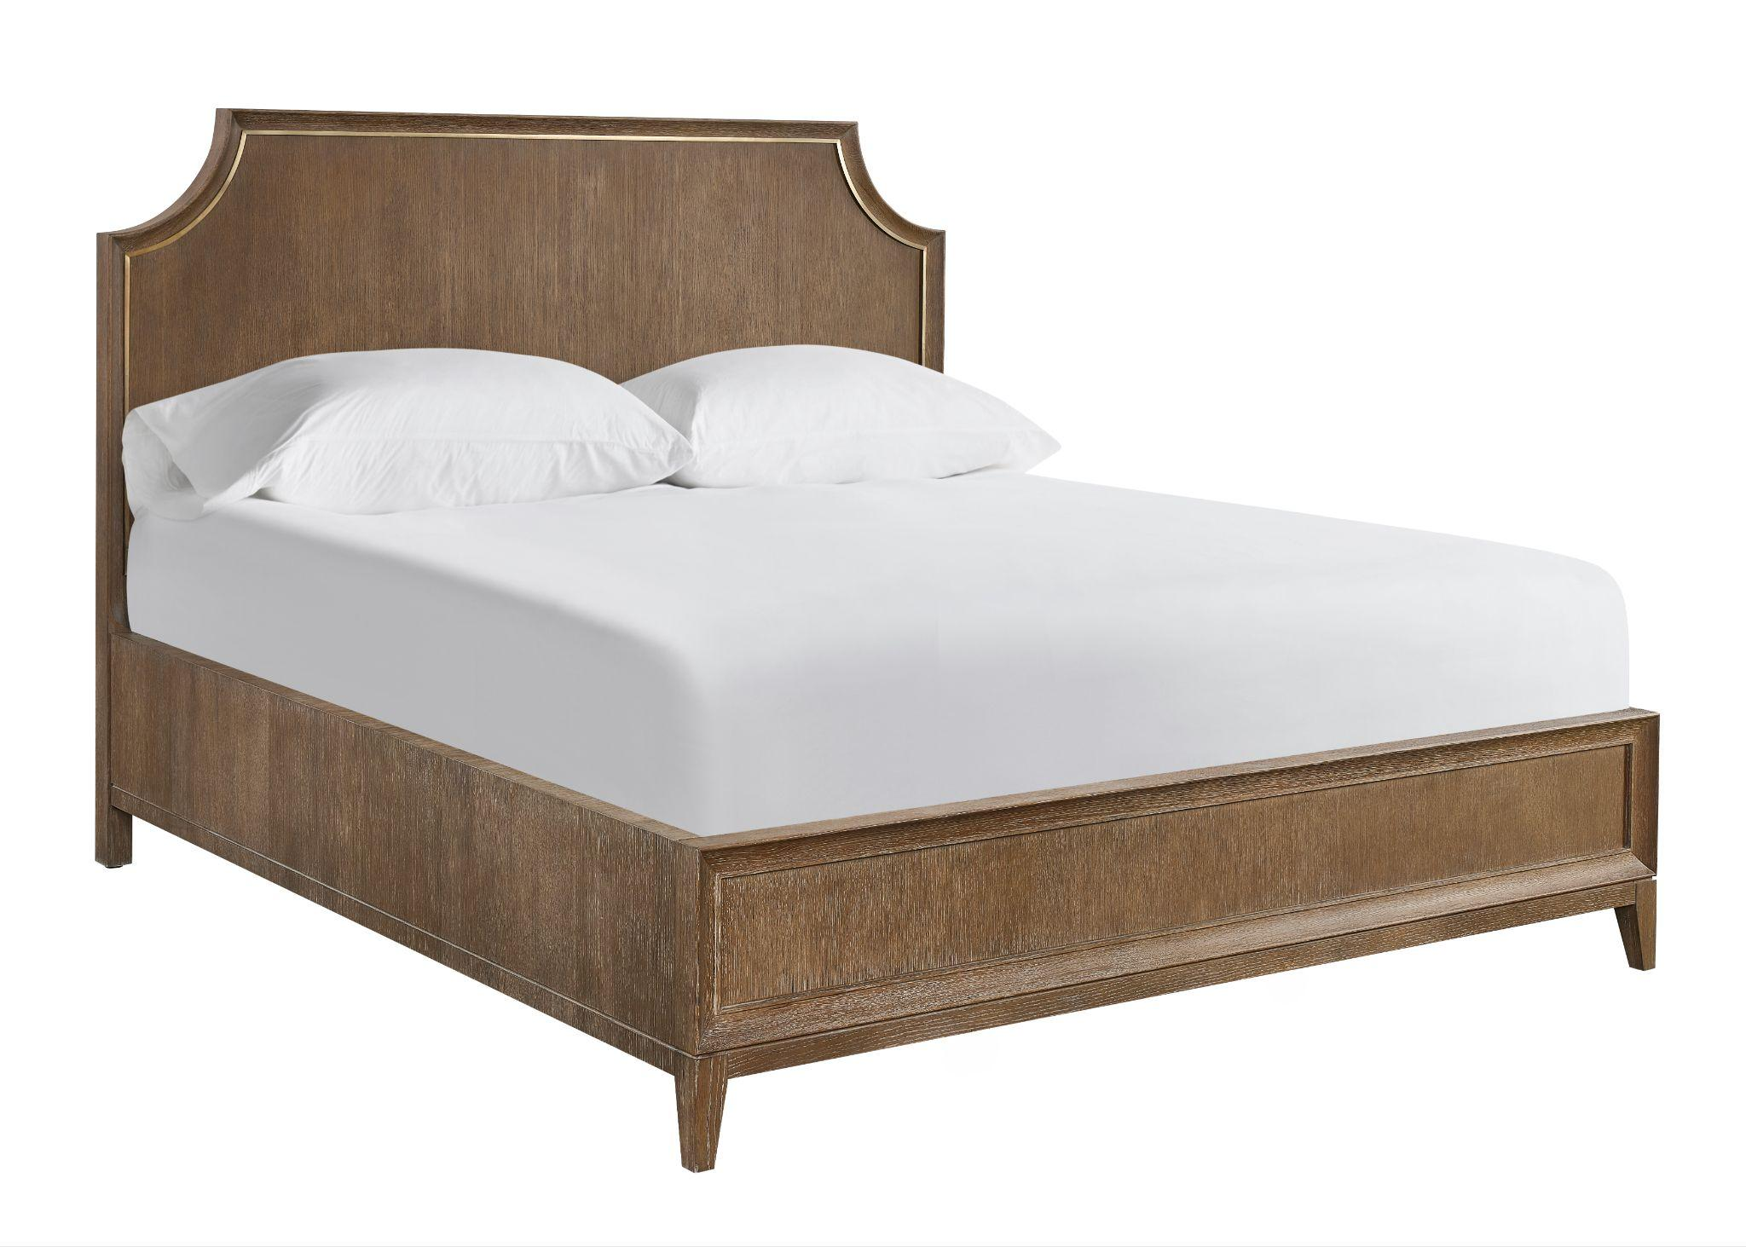
Emerie Panel Bed
The ultimate in understated sophistication, the Emerie Panel Bed has a warm, dark oak finish and features a dusty bronze metal trim that follows the shape of the notched headboard.

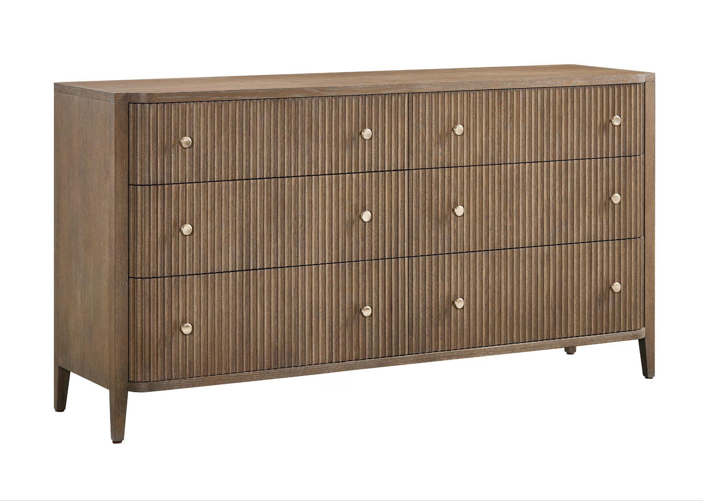

Emerie Six-Drawer Chest
The six-drawer chest boasts generous storage and a refined, architectural presence. Vertical fluting across the drawer fronts creates texture and rhythm, while rounded corners and tapered legs lend a graceful quality. Round drawer pulls in Dusty Bronze provide a polished finishing touch.

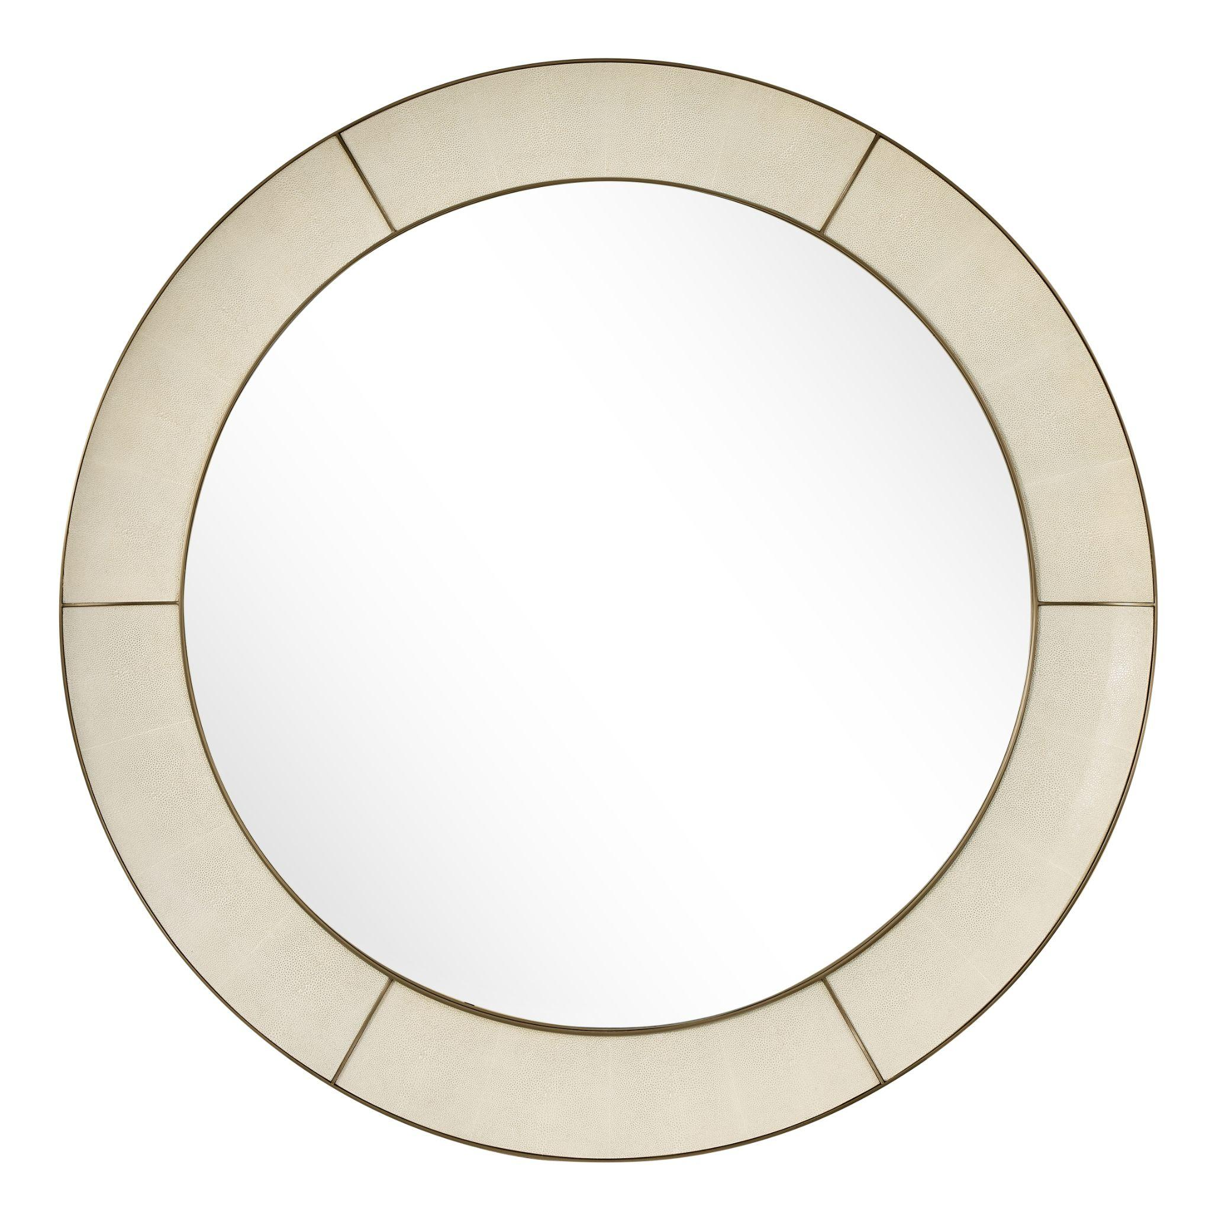
Emerie Dusty Bronze Mirror
At 42 inches in diameter, this circular mirror makes a sophisticated statement with a wide shagreen-wrapped frame divided into subtly articulated panels. Slim dusty bronze metal trim outlines each section, adding warmth and definition.

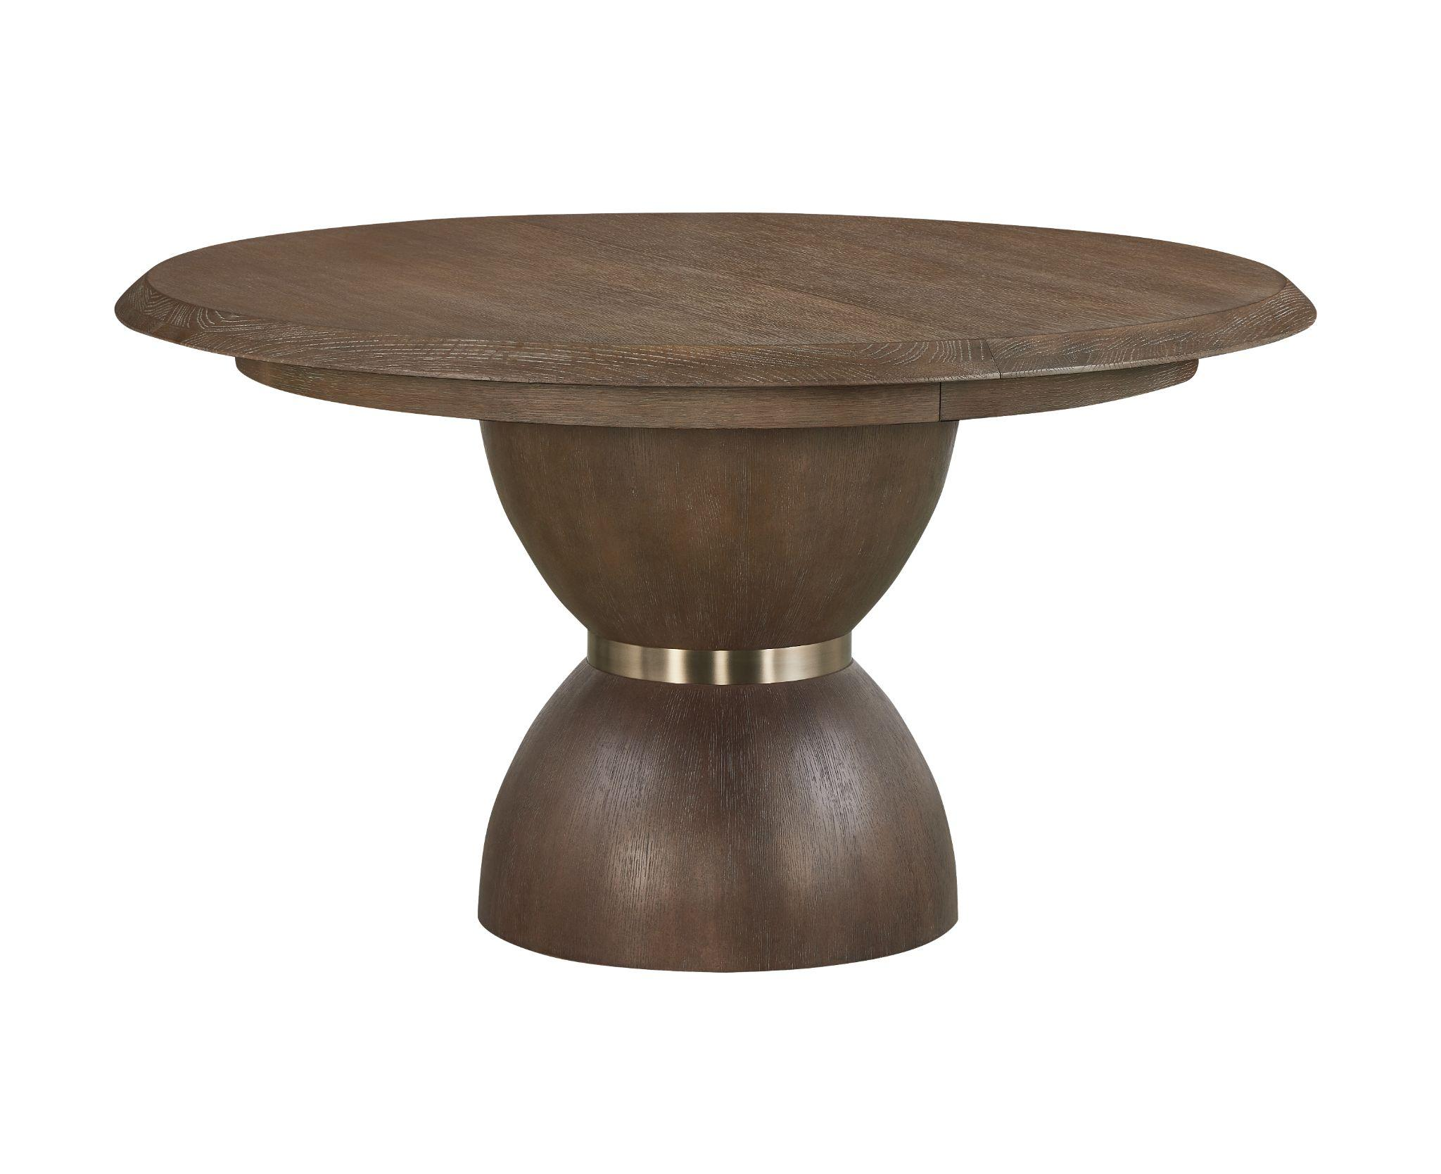

Emerie Round Dining Table
This table brings a worldly presence to the dining room. Its hourglass pedestal features two curved forms joined by a Dusty Bronze metal band, creating a corset silhouette. A softly beveled edge accentuates the 54-inch round top, while optional leaves expand the table for larger gatherings.

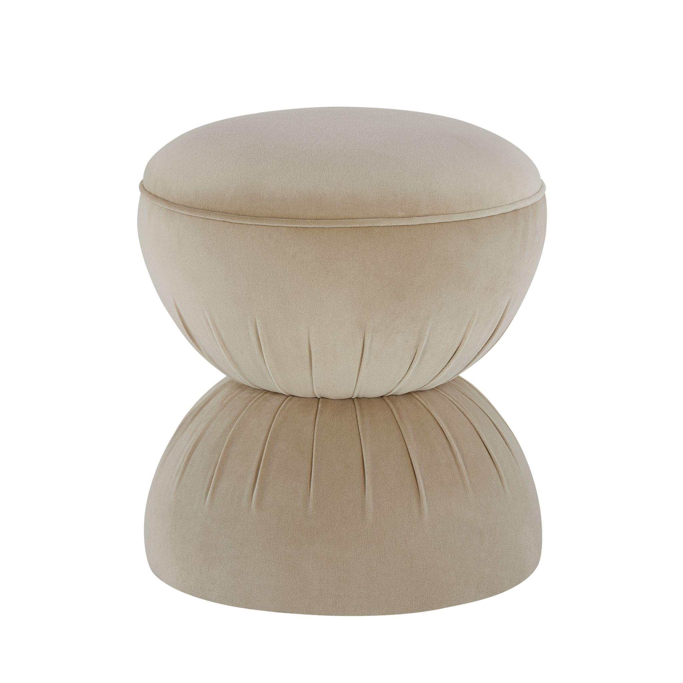

Emerie Opal Ottoman
Serving as a soft place to land, the Emerie Opal Ottoman brings a playful sculptural element to the collection. Its rounded, fully upholstered form narrows at the center, where tailored pleating accentuates the corset silhouette. Measuring 18 inches wide by 18 inches deep by 19 inches high, the compact ottoman can serve as extra seating, a footrest or a charming accent piece.
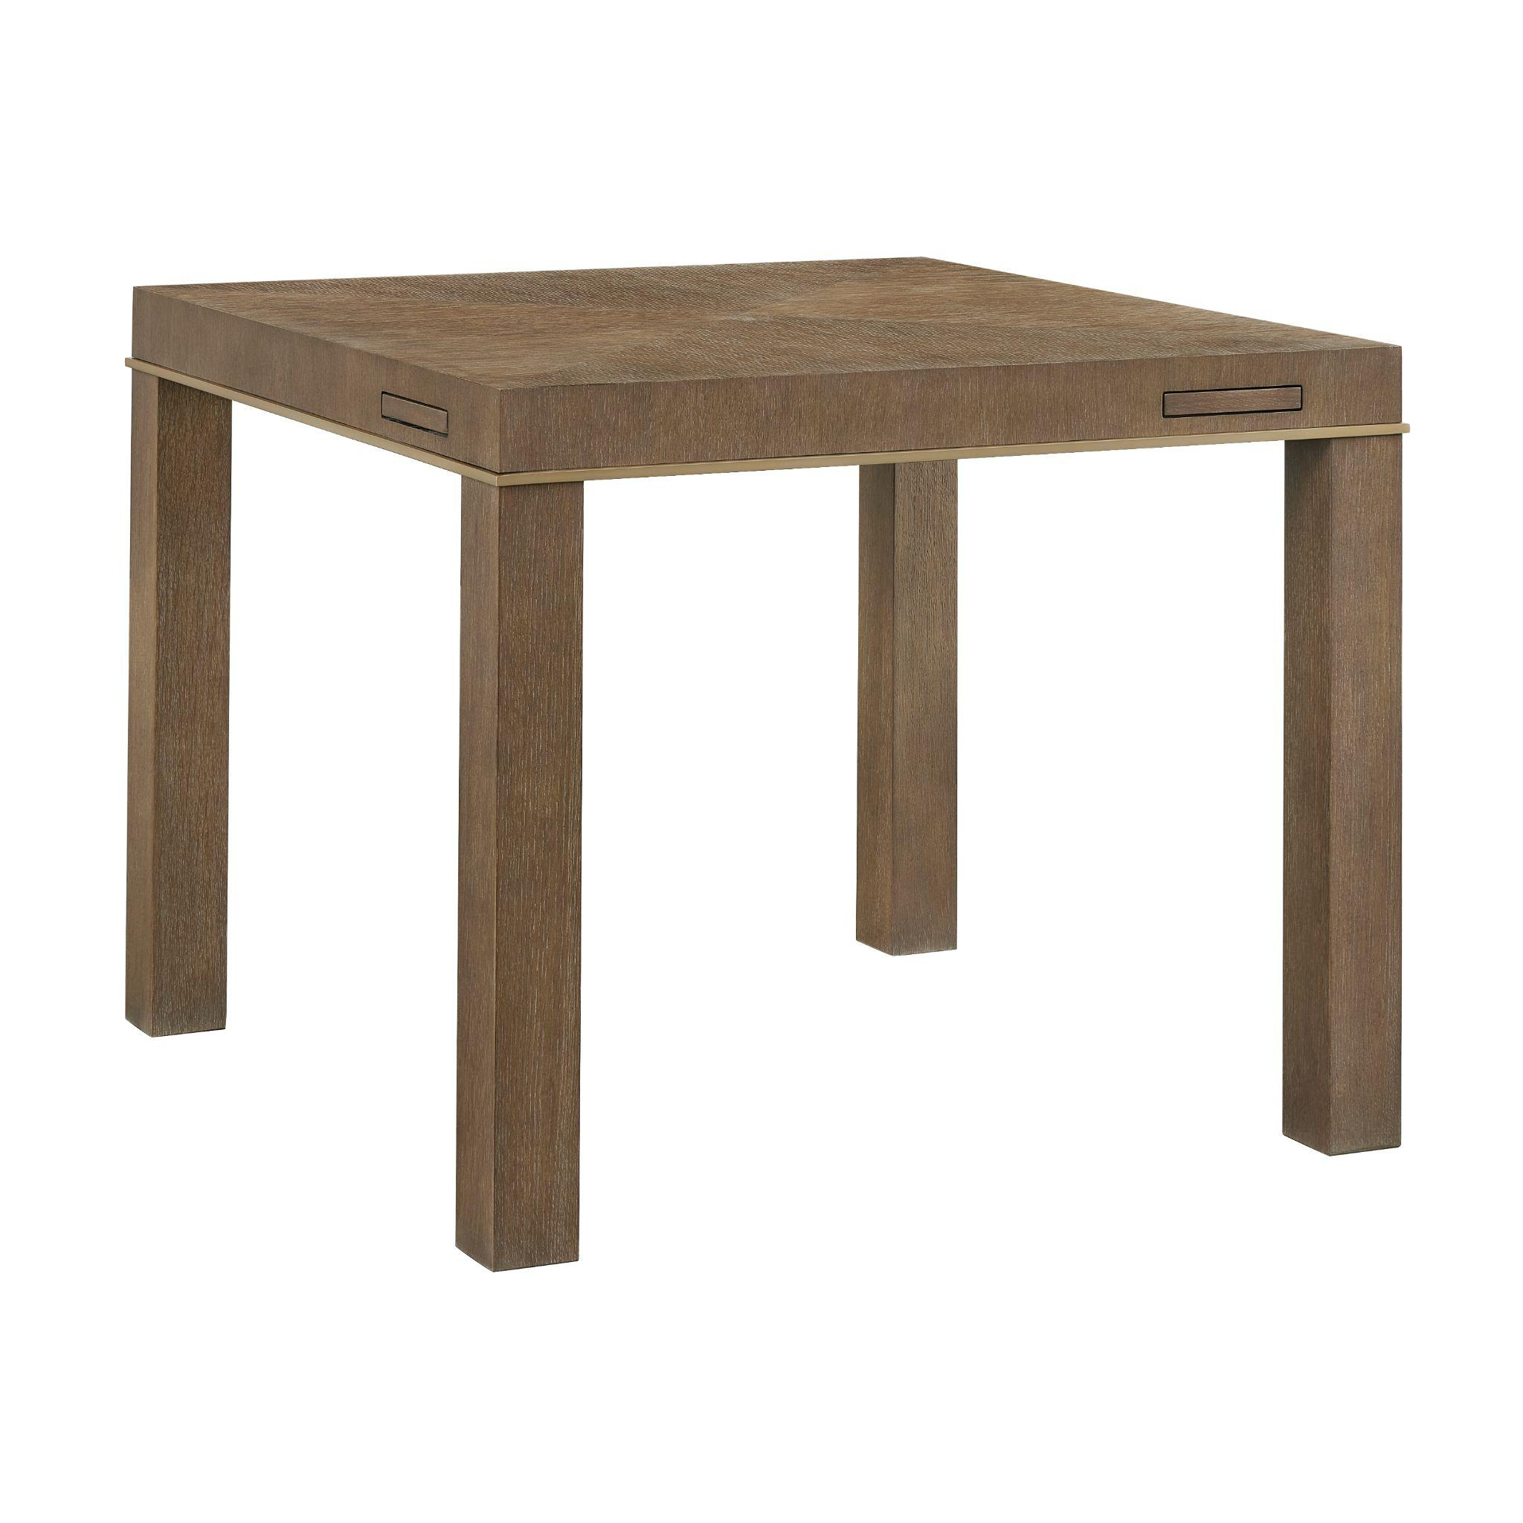
Emerie Game Table
Responding to renewed enthusiasm for Mahjong, card games and gathering around the table, the Emerie Game Table brings elevated design to a favorite social pastime. Diamond-matched veneers create subtle movement across the square top, while Dusty Bronze metal trim adds a tailored accent. Integrated pop-out drink coasters offer convenience, making the table equally suited to game night or everyday use.

# # #
About Universal
Retailers and interior designers around the world trust Universal Furniture’s award-winning, smart and stylish designs to create modern, well-appointed living spaces for the whole home. The company’s casegood, upholstery, accent and outdoor designs are developed under the brand names Universal Furniture, Miranda Kerr Home and Coastal Living.

Universal Furniture, founded in 1968 and based in High Point, N.C., is the recipient of 14 Pinnacle awards for design excellence from the International Society of Furniture Designers. It is a brand of Samson Holdings, one of the world’s largest vertically integrated furniture manufacturers. For more information, please visit www.universalfurniture.com, or find us on Facebook, Instagram, and Pinterest @UniversalFurn.

