‘

FOR IMMEDIATE RELEASE SHOWROOM: 101 S. Hamilton

Contact: Mary Leigh Howell
ml@maryleighhowell.com
(336) 317-7713

Universal Furniture and Coastal Living Introduce a
Colorful Weekend Getaway
IMAGES: https://www.dropbox.com/scl/fo/8l9v3c9gs1k6qx0kt9rl2/ANBUDMZnW2IbgiNFUzCh7Zw?rlkey=geomsat9wc7w0rp1cjw47rdfe&st=gngzkg0p&dl=0
HIGH POINT, N.C., Oct. 12, 2026 – Universal Furniture and Coastal Living will introduce Weekend Getaway, a 20-piece capsule collection designed to complement the brands’ existing coastal furnishings, at Fall High Point Market. The two brands’ have collaborated for years, beginning in 2018.
“Weekend Getaway captures the easy, collected quality that has made our partnership with Coastal Living so successful,” said Sean O’Connor, president of Universal Furniture. “It introduces fresh color and character while working naturally with the collections our customers already know and love.”
Blending the ease of European seaside living with classic American coastal style, Weekend Getaway pairs relaxed forms and woven details with light oak and softly painted finishes. White Quartz, Brushed Champagne metal and performance upholstery complete the collection’s casual, livable palette.
Color plays a central role, with select pieces offered in Marina, a deep blue; Cabana, a warm off-white; Cove, a soft blue; and Cypress, a sage green. The campaign chest is also available in four coordinating linen finishes created using the traditional gesso technique, giving the surface a subtle linen-like texture and depth.
Designed to mix easily with previous Coastal Living collections, Weekend Getaway offers a spirited update to a familiar coastal aesthetic, with pieces suited to a range of interiors.
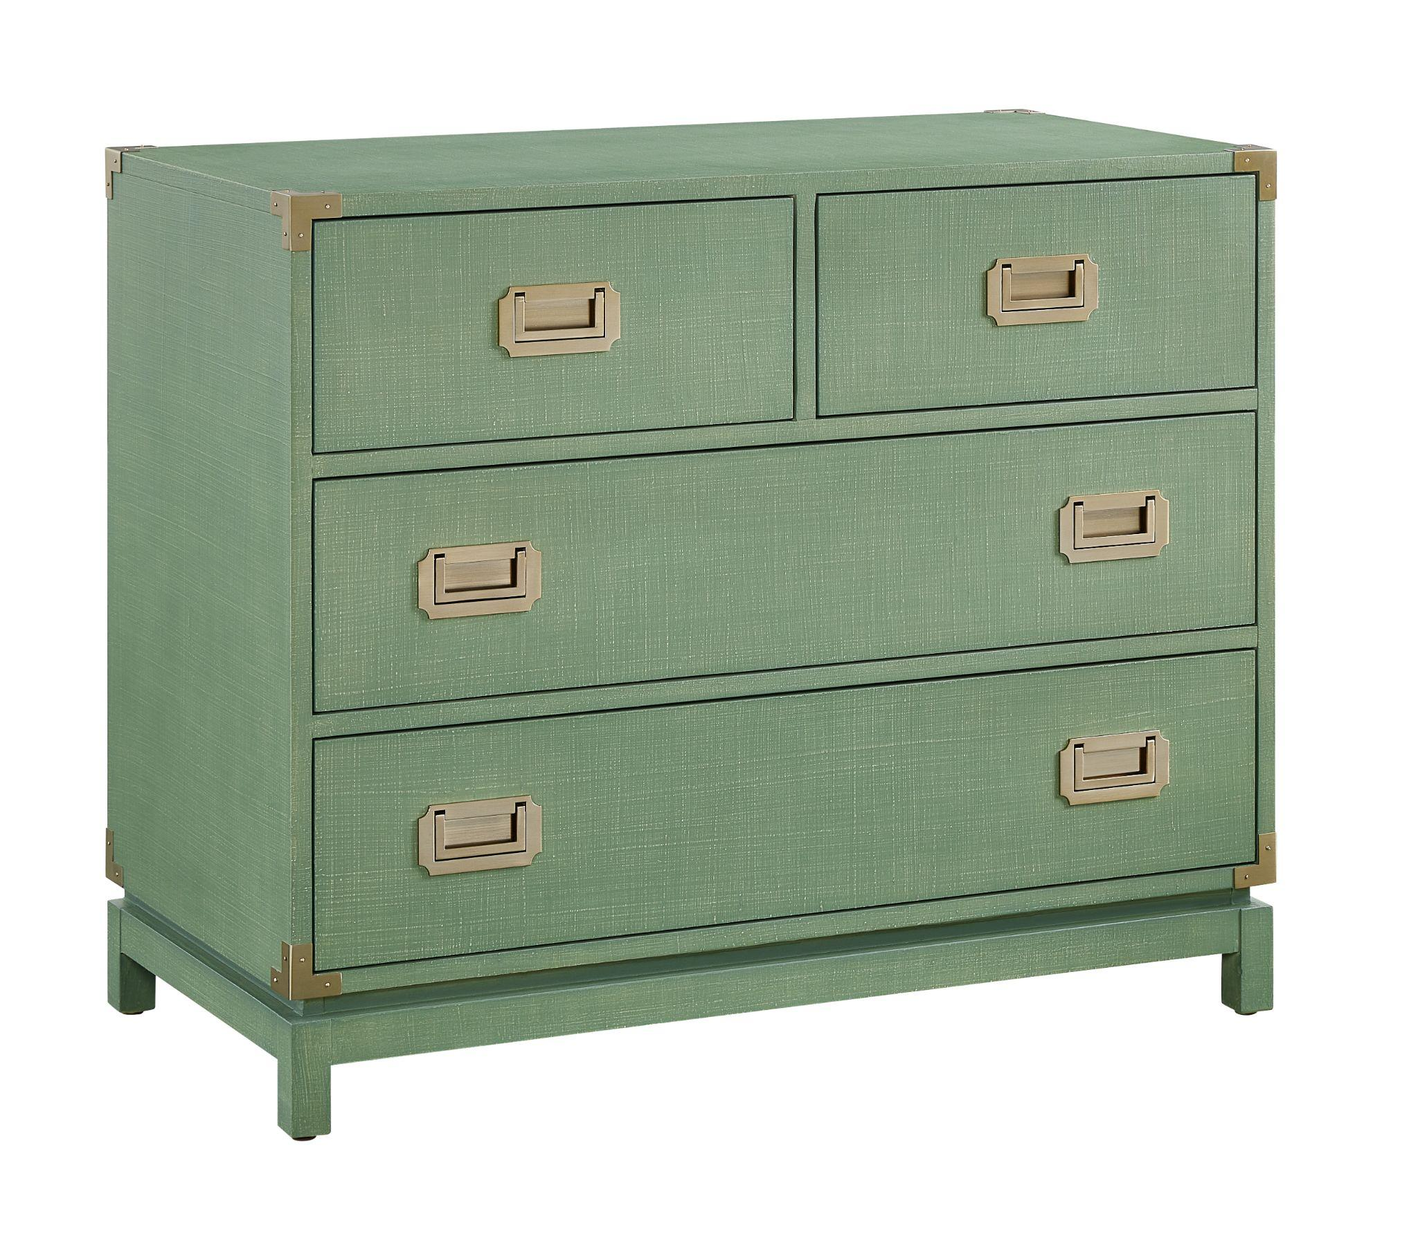
Weekend Getaway Campaign Chest
Classic campaign styling takes on a fresh coastal character in a chest refreshing new Cypress Linen textured finish. Campaign hardware in brushed champagne finish and recessed pulls provide a warm metallic contrast. The chest is also offered in Marine Linen, Cabana Linen and Cove Linen.
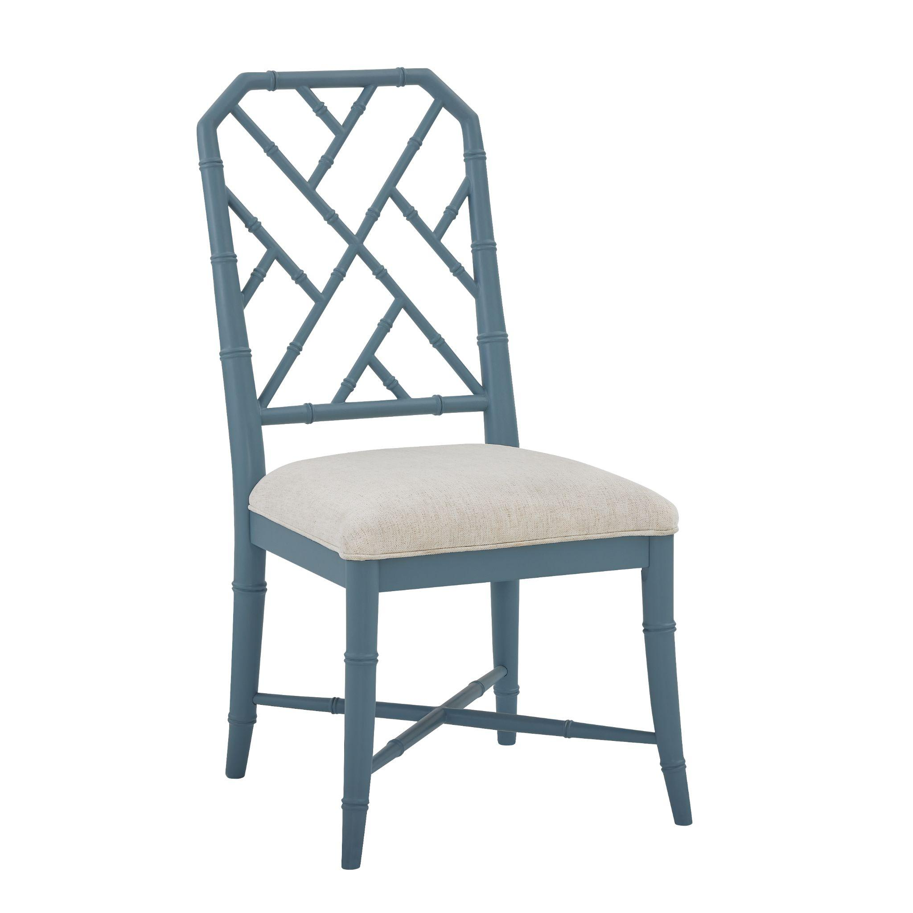
Weekend Getaway Dining Chair
Bamboo-inspired detailing and an open fretwork back give the dining chair its breezy coastal character. Shown in the soft blue Cove finish with a comfortably upholstered seat, the chair is also available in Cypress, Marina and Cabana.
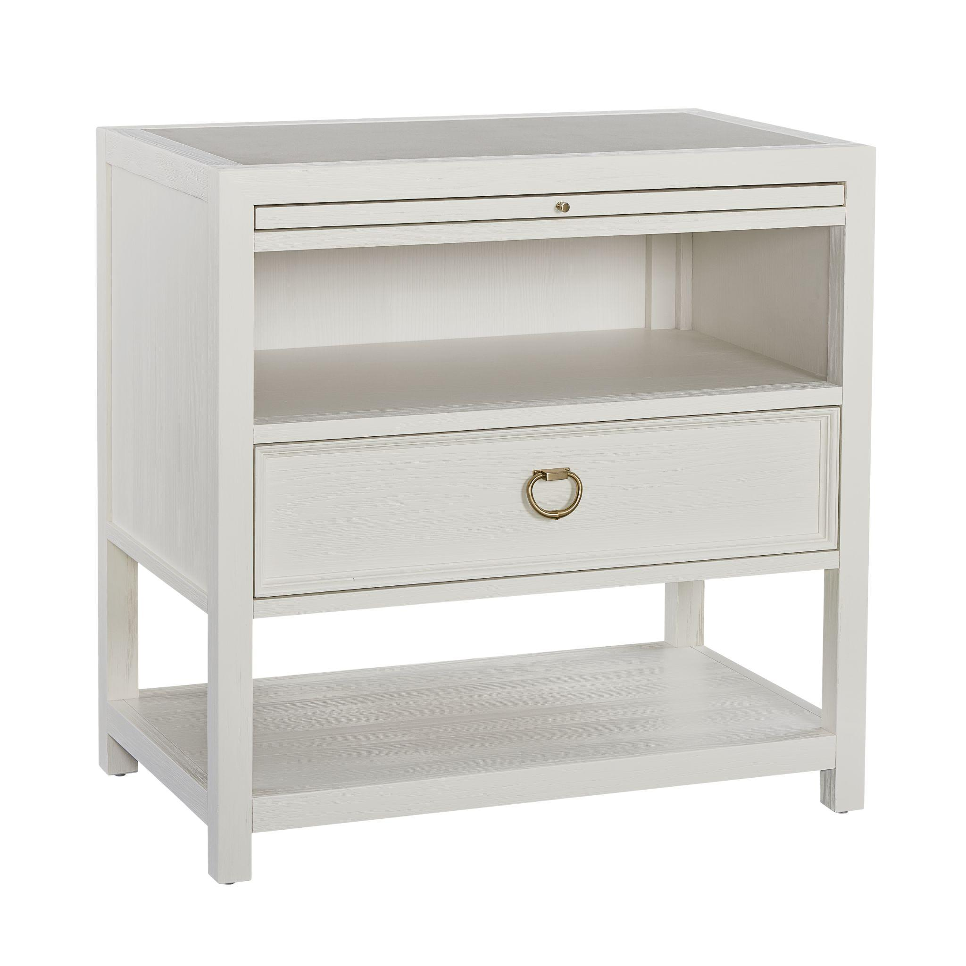
Weekend Getaway Sugar Sand Nightstand
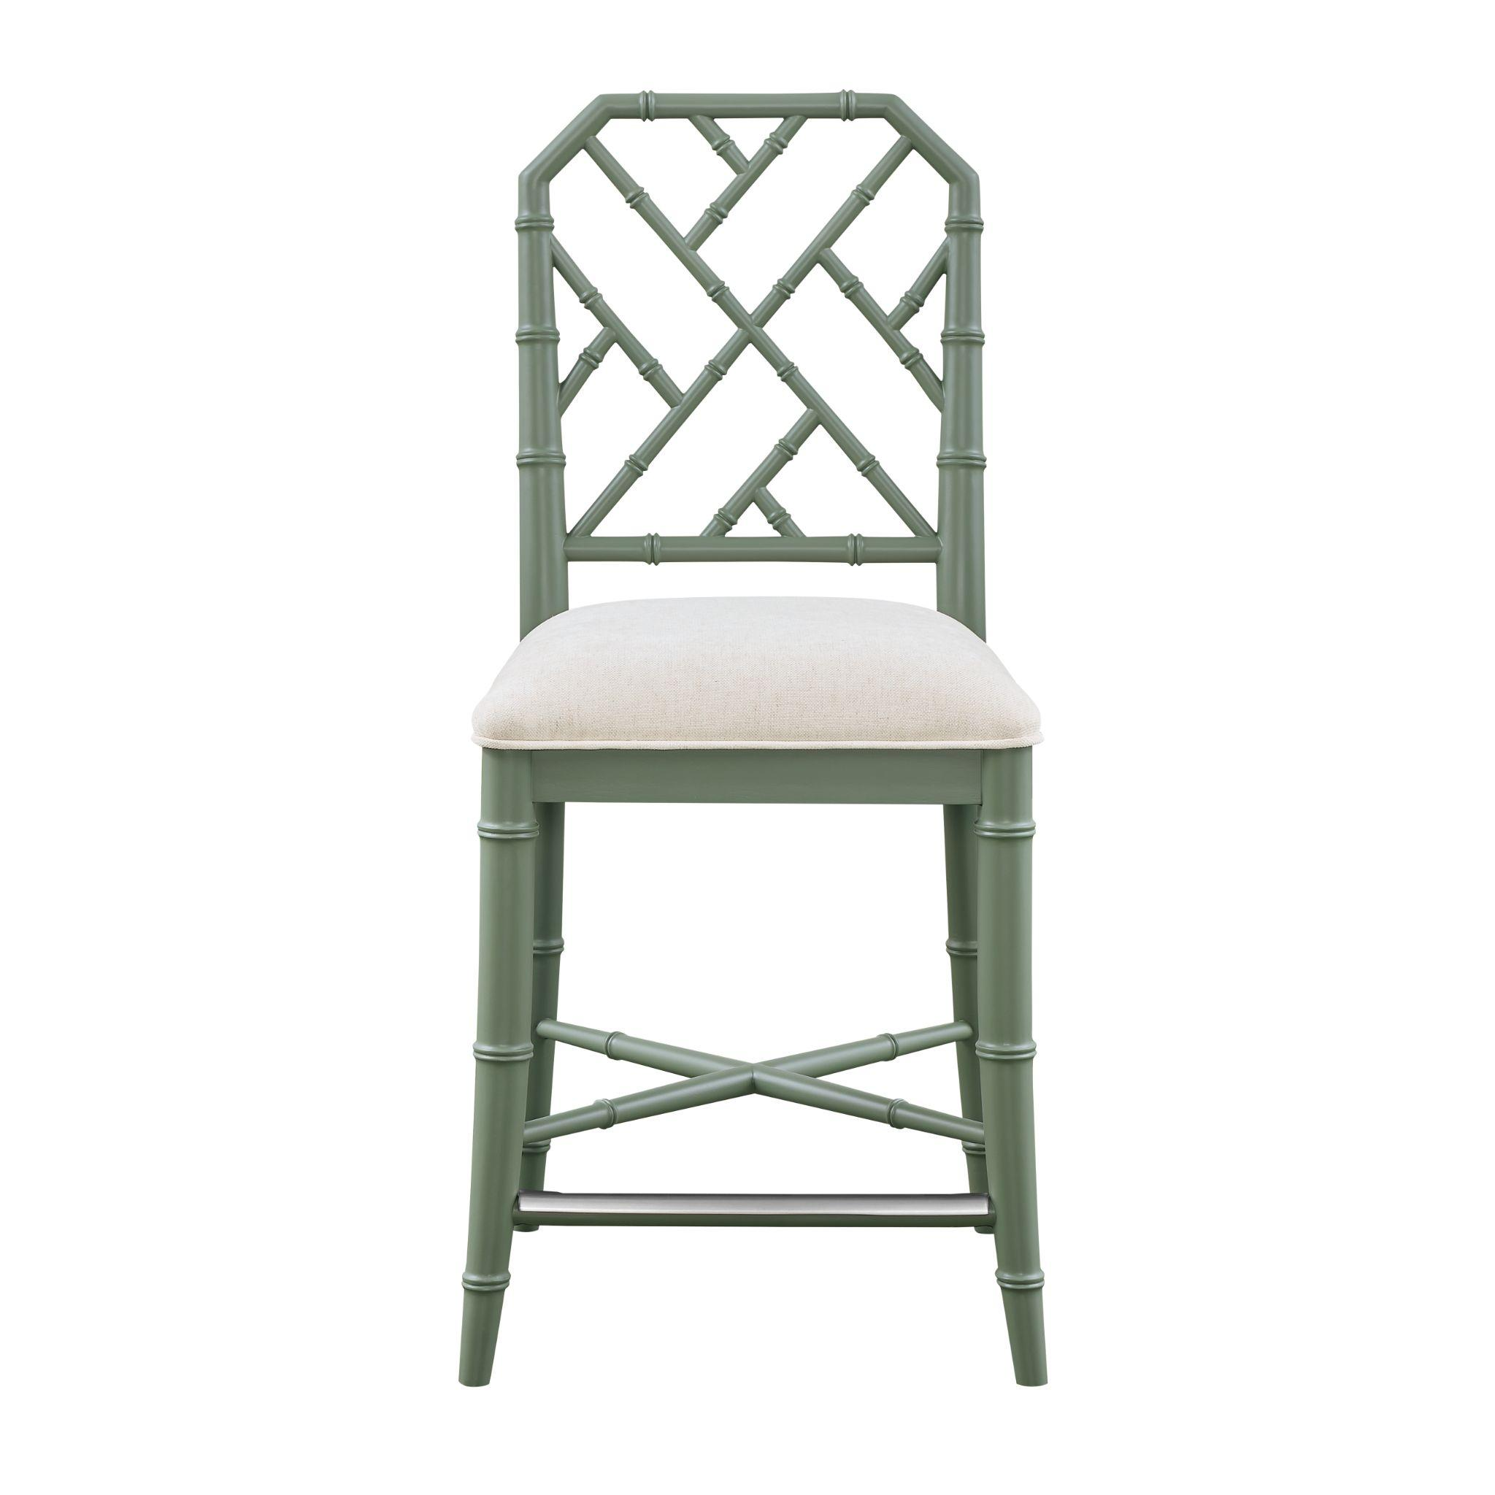
The Sugar Sand Nightstand pairs a lightly wire-brushed white finish with a durable inset White Quartz top. A pullout panel nearly doubles the surface area, while a drawer, open shelf and enclosed storage provide bedside versatility. Brushed Champagne ring-pull hardware completes the look.

Weekend Getaway Counter Stool
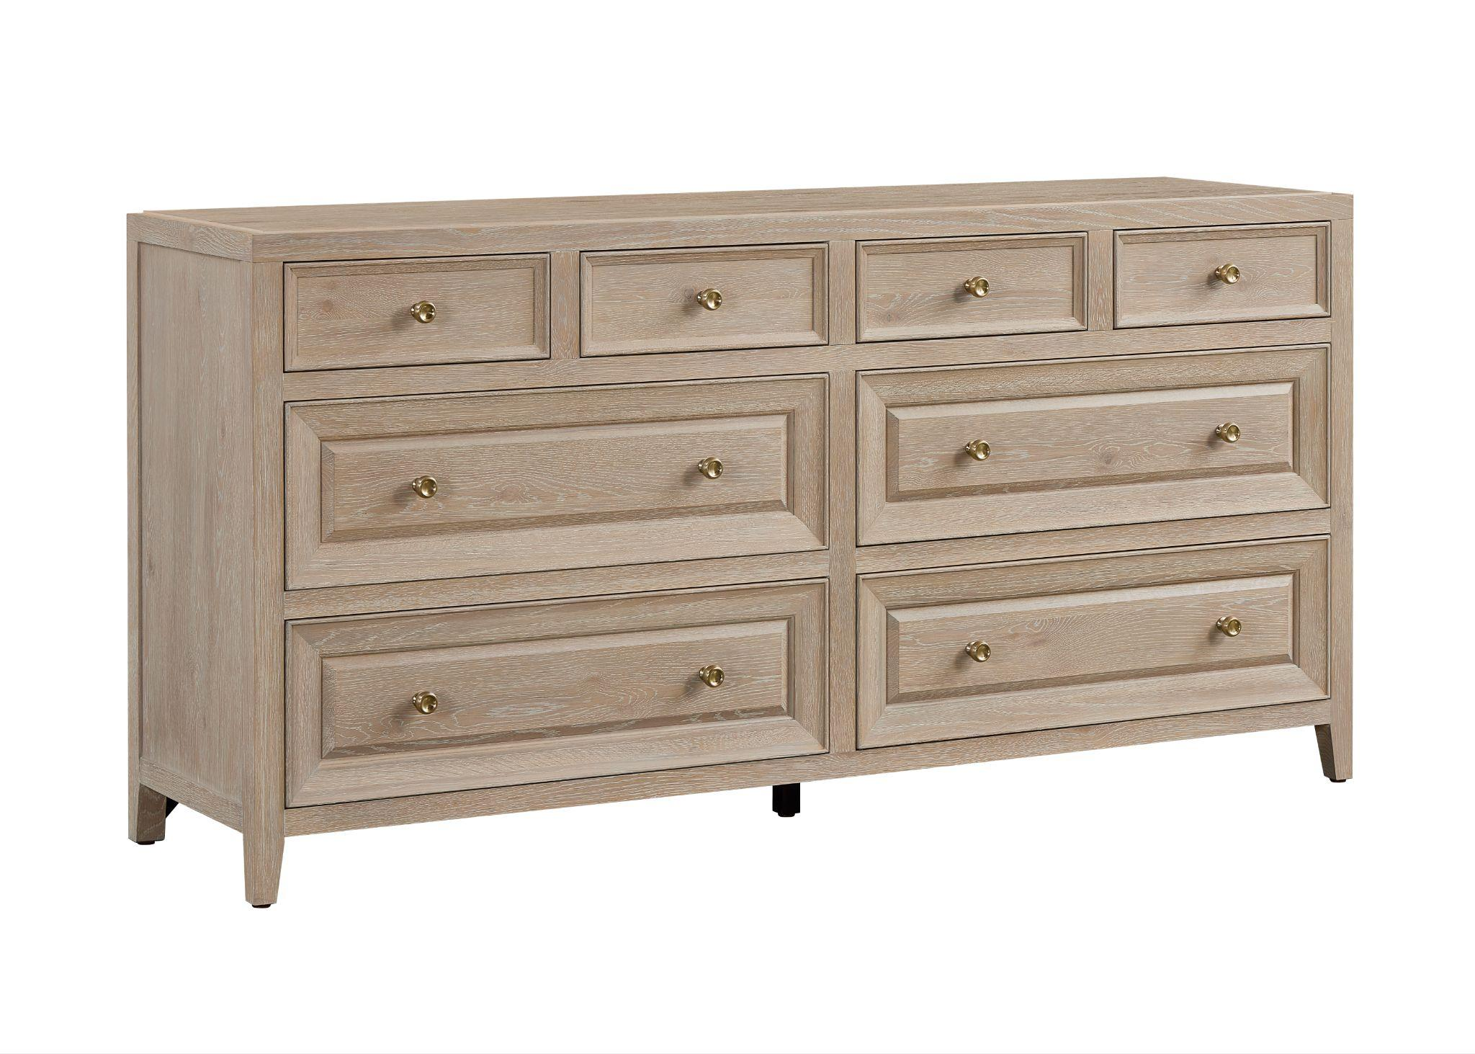
Bamboo-inspired detailing and an open fretwork back give the counter stool a relaxed coastal feel. Shown in the sage green Cypress colorway, it features a comfortably upholstered seat, crossed stretchers and a metal footrest. The stool is also available in Cove, Marina and Cabana.

Weekend Getaway Bluff Dresser
The Bluff Dresser pairs a clean silhouette with refined trim details. Eight inset drawers, including four smaller drawers above four larger drawers, are framed with molding and finished with indented knobs in Brushed Champagne.

# # #
About Universal
Retailers and interior designers around the world trust Universal Furniture’s award-winning, smart and stylish designs to create modern, well-appointed living spaces for the whole home. The company’s casegood, upholstery, accent and outdoor designs are developed under the brand names Universal Furniture, Miranda Kerr Home and Coastal Living.

Universal Furniture, founded in 1968 and based in High Point, N.C., is the recipient of 14 Pinnacle awards for design excellence from the International Society of Furniture Designers. It is a brand of Samson Holdings, one of the world’s largest vertically integrated furniture manufacturers. For more information, please visit www.universalfurniture.com, or find us on Facebook, Instagram, and Pinterest @UniversalFurn.

