

FOR IMMEDIATE RELEASE SHOWROOM: 101 S. Hamilton

Contact: Mary Leigh Howell
ml@maryleighhowell.com
(336) 317-7713

Universal Furniture Embraces Artful Individuality with New Cassia Collection
IMAGES: https://www.dropbox.com/scl/fo/8l9v3c9gs1k6qx0kt9rl2/ANBUDMZnW2IbgiNFUzCh7Zw?rlkey=geomsat9wc7w0rp1cjw47rdfe&st=gngzkg0p&dl=0

HIGH POINT, N.C., Oct. 12, 2026 – Cassia, an expansive whole-home collection inspired by the artful mix of furnishings and objects gathered over time, will debut at Fall High Point Market. As one of the company’s largest introductions of the season, Cassia spans bedroom, kitchen, dining, living and work spaces.

Influenced by postmodernism and pop art, Cassia pairs clean silhouettes with playful geometry, saturated color and unexpected contrasts. The collection reflects the sensibility of a creative collector, bringing together furniture, art, and personal objects in spaces that feel curated yet not overly composed.
The majority of designs in Cassia are crafted in white oak, finished in a softly wire-brushed medium tone that provides a warm foundation, complemented by Dusty Bronze accents and a varied selection of richly patterned stones. An off-white alternate finish, called Flax, presents a contrast seen in game tables and small case pieces.
Tailored upholstery in neutral fabrics and leather rounds out the collection, balancing its more expressive elements with comfort and versatility.
“Cassia is one of our most expansive introductions, but it still feels personal,” said Sean O’Connor, president of Universal Furniture. “There is a sense of creativity and confidence throughout the collection, with pieces that can stand on their own while giving designers and homeowners the freedom to create spaces that feel distinctly their own.”
Throughout Cassia, expressive materials and unexpected details bring character to clean, modern forms. Highlights from the collection include:
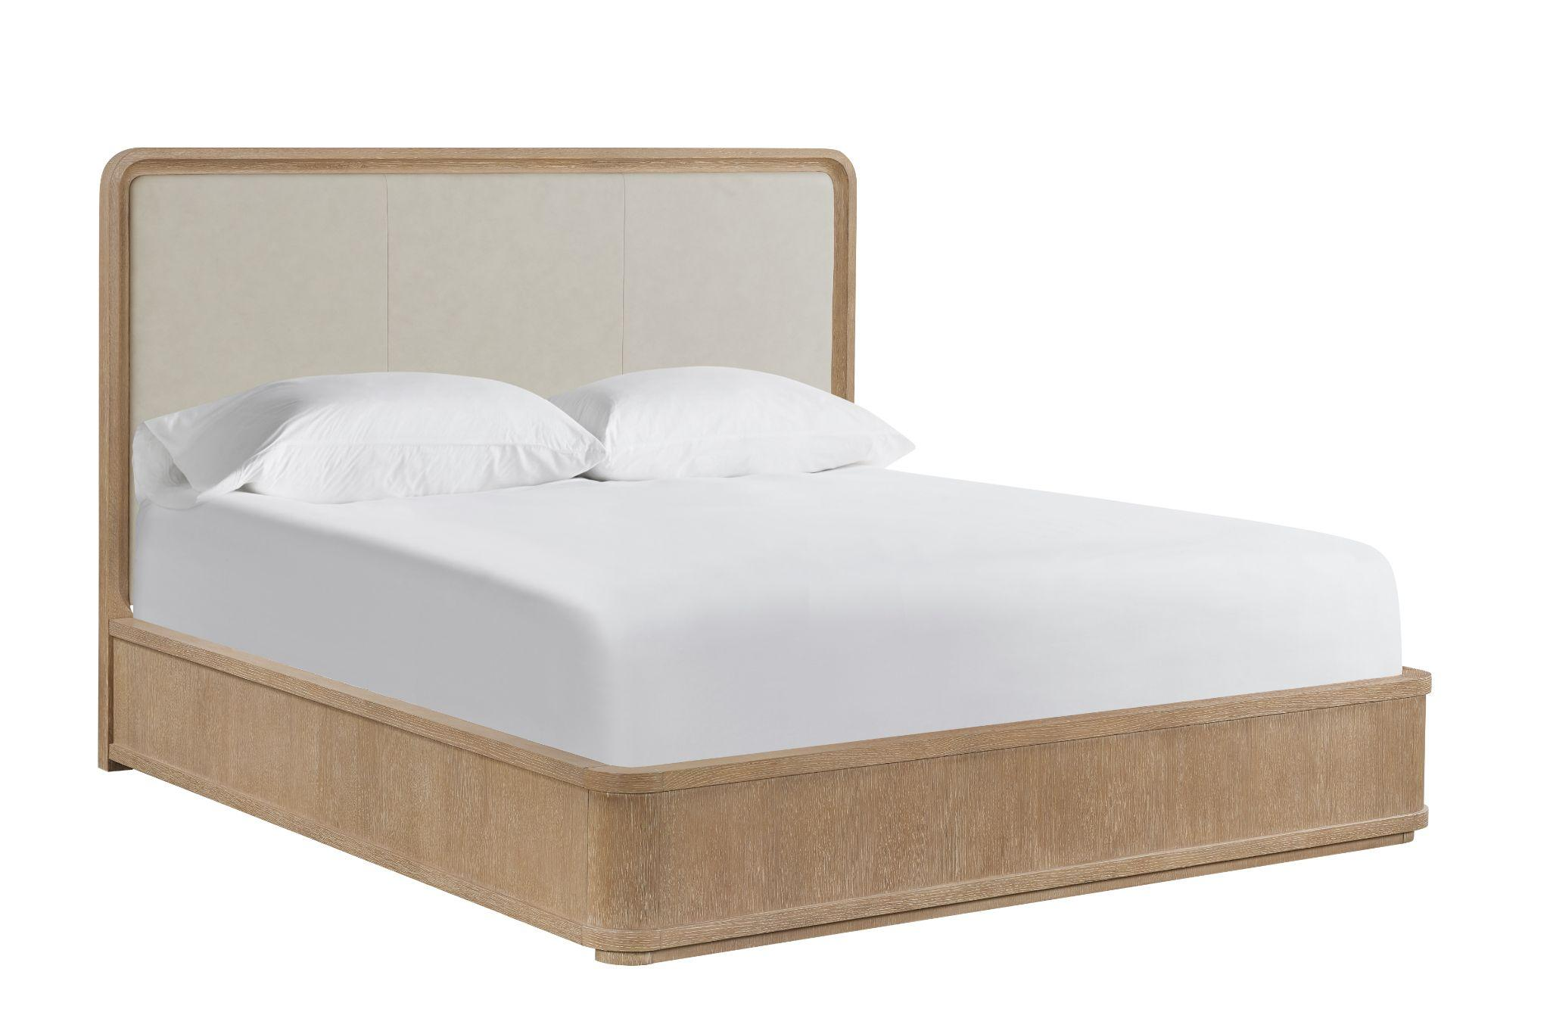
Cassia upholstered bed
Softly rounded white oak frames three, inset leather panels on the headboard create a tailored contrast of texture and material. A wire-brushed finish highlights the wood grain across the headboard trim, footboard and rails.
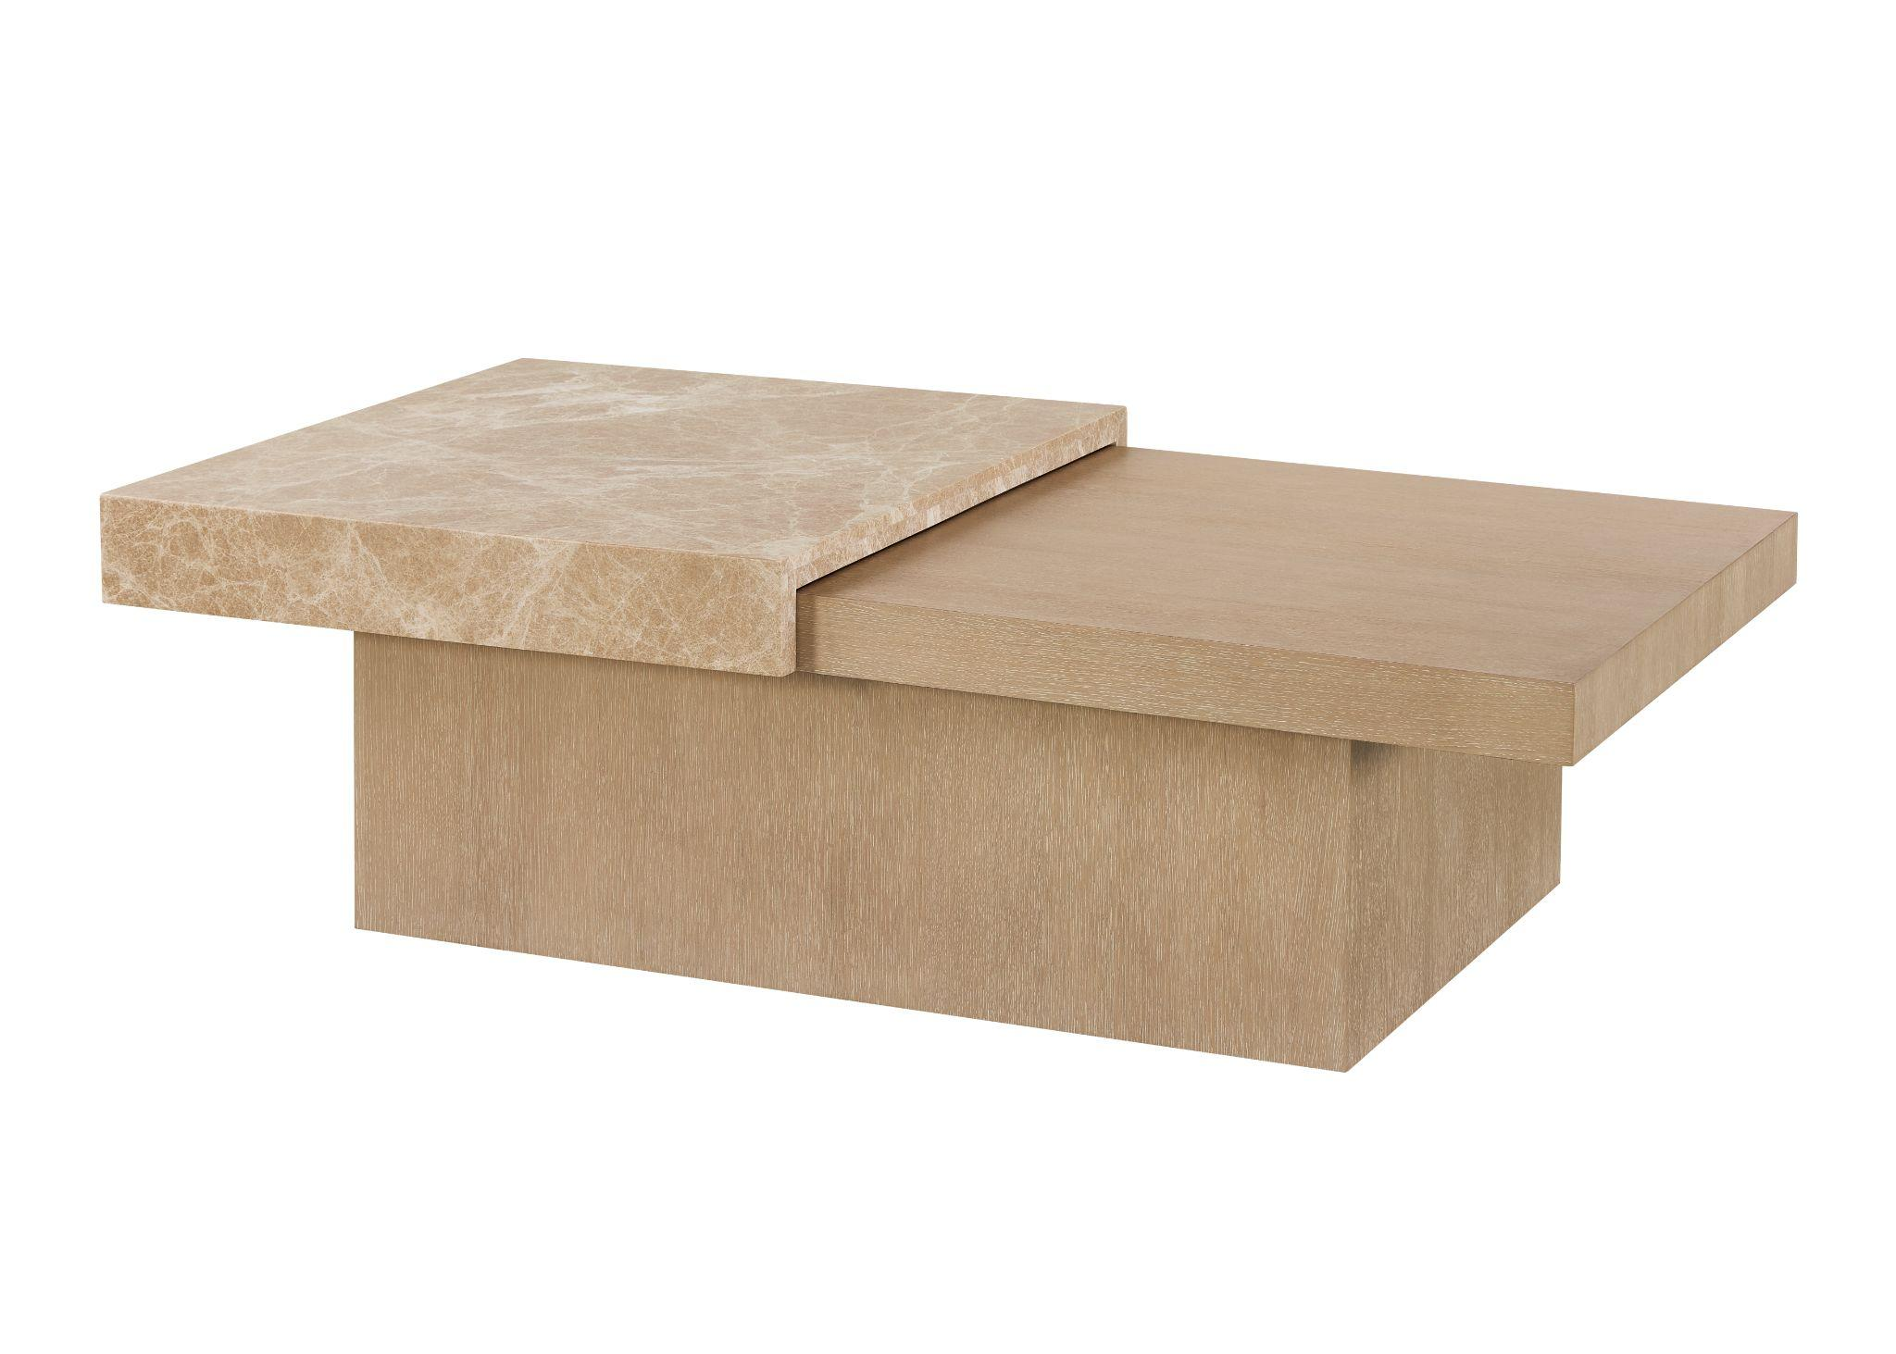
Cassia Storage Cocktail
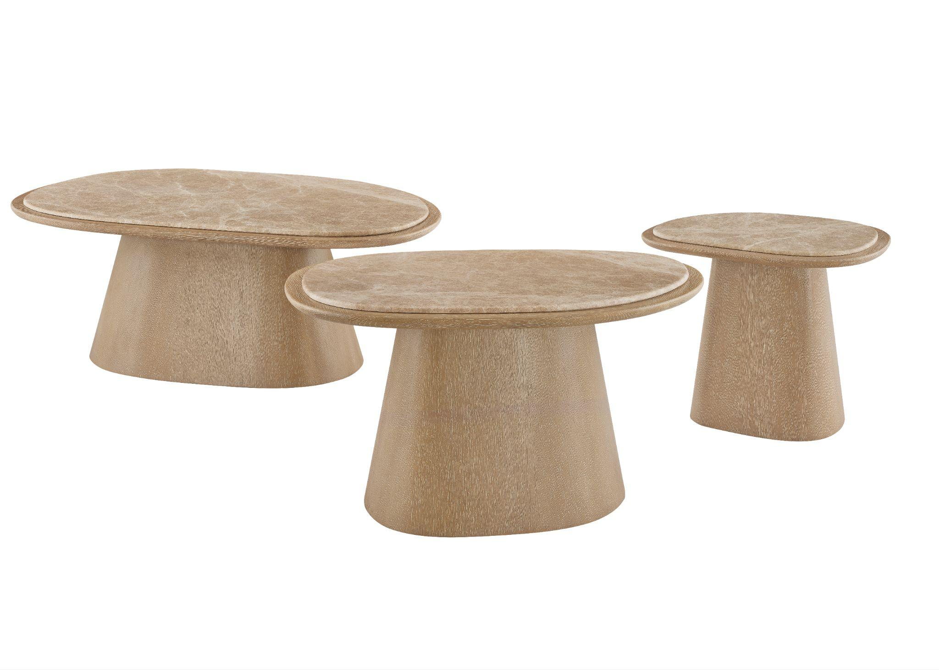
Overlapping stone and wood surfaces give the cocktail table a graphic, layered appearance. The top slides open to reveal concealed storage, bringing unexpected function to its low, architectural form.

Cassia Nesting Tables
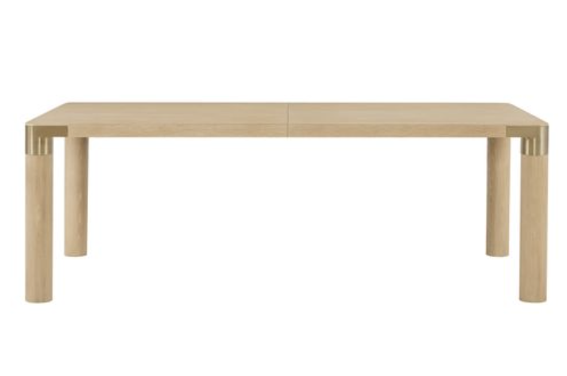
Designed as a trio, the nesting tables pair organically shaped tops with sculptural bases. Top surfaces feature light Emperador stone which introduces natural variation and provides a contrast to the warm wood.

Cassia Dusty Bronze Dining Table
A rectangular dining table with slender, cylindrical legs, featuring dusty bronze metal joinery. Comes with a 22-inch leaf.

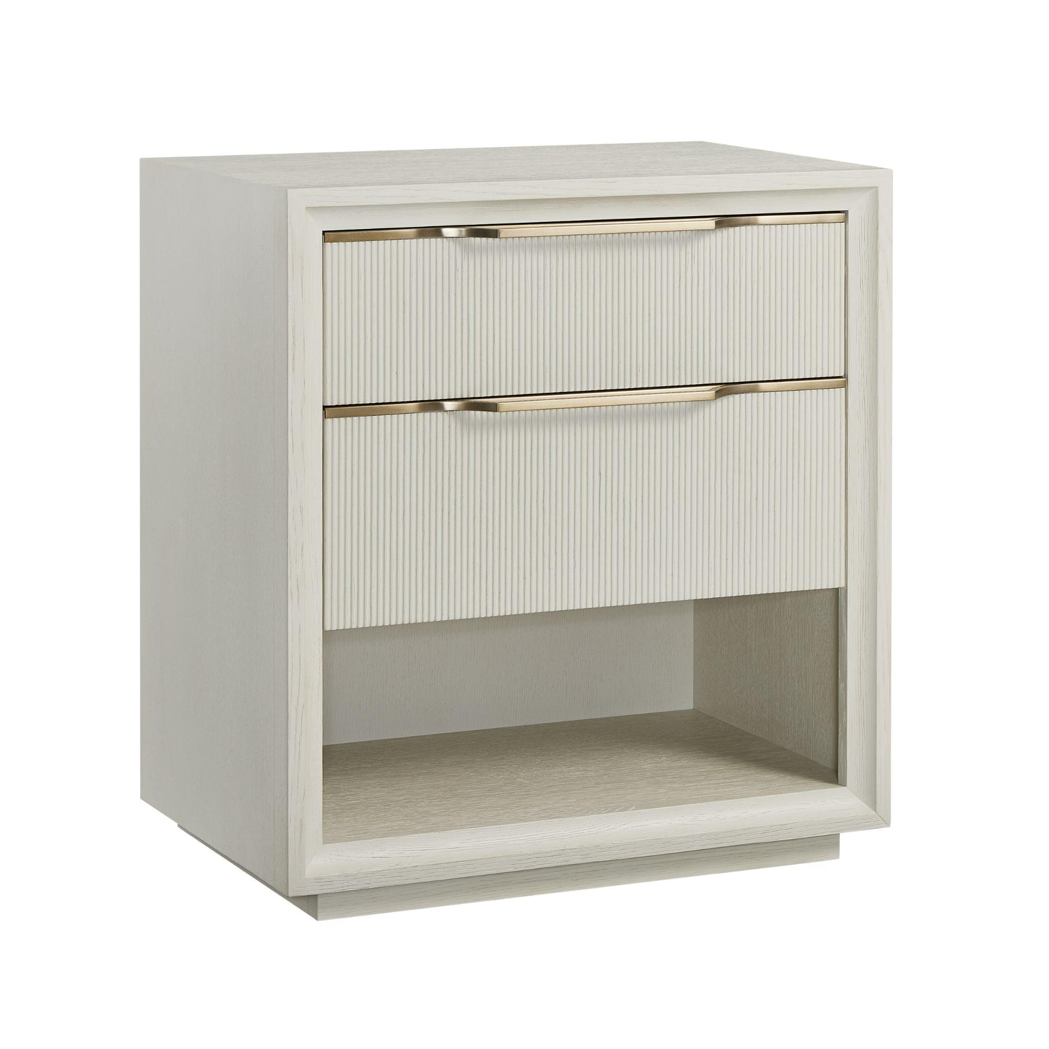
Cassia Flax Nightstand
At 28 inches wide, this fairly compact, two-drawer nightstand layers a lot of detail into a clean silhouette. Reeded drawer fronts feature slender, Dusty Bronze hardware that’s built into the drawer top, and appear as door trim, with an extruding handle. A plinth base and perimeter trim frame the case.

# # #
About Universal
Retailers and interior designers around the world trust Universal Furniture’s award-winning, smart and stylish designs to create modern, well-appointed living spaces for the whole home. The company’s casegood, upholstery, accent and outdoor designs are developed under the brand names Universal Furniture, Miranda Kerr Home and Coastal Living.

Universal Furniture, founded in 1968 and based in High Point, N.C., is the recipient of 14 Pinnacle awards for design excellence from the International Society of Furniture Designers. It is a brand of Samson Holdings, one of the world’s largest vertically integrated furniture manufacturers. For more information, please visit www.universalfurniture.com, or find us on Facebook, Instagram, and Pinterest @UniversalFurn.

