

FOR IMMEDIATE RELEASE

Sarreid Ltd. Launches Curators Circle to Bring Designer Insight
Into Product and Brand Development
New advisory group will help shape product mix, merchandising and the way
Sarreid can serve designers and retailers

WILSON, N.C. Sept. 24, 2026 —Sarreid Ltd. is creating a new Curators Circle, an advisory group of respected design and industry voices who will help the company look more deeply at what it makes, how it develops and presents product and how those decisions can better support the designers and retailers who bring Sarreid into homes and projects around the country.
The Circle is part of Sarreid’s broader evolution around the idea of modern heirlooms for the collected home: furnishings with lasting character, craftsmanship and relevance rather than a point of view driven by short-lived trends. Its members will give Sarreid an outside perspective from people who specify, sell and work with furnishings in real-world settings, helping the company identify opportunities, question assumptions and keep its product and merchandising decisions closely connected to the marketplace.
“We have a strong history and a strong point of view, but deepening the business means making sure we keep listening to the people who are closest to the customer,” said Brad Cates, president and chief executive officer of Sarreid Ltd. “The Curators Circle gives us a thoughtful way to do that. We want candid voices around us — people who will tell us what is working, what could be stronger and where they see opportunity. That kind of exchange can make Sarreid better at every level, from the products we create to the relationships we build with the people who sell and specify them.”
Curators Circle members will be invited into Sarreid’s product review and development process, offering insights, recommendations and critiques that can inform new concepts, materials, finishes, categories and assortments. Their perspective will also extend to merchandising and presentation — helping Sarreid consider not only whether an individual piece is compelling, but how it belongs within a broader collection and how that collection can become a more useful business tool for the trade.
“The best product conversations include both enthusiasm and pushback,” said Mickey Sharpe, vice president of design and creative for Sarreid Ltd. “We want the Circle to react honestly to what we are developing, tell us what they believe is missing and help us see the product through the eyes of the people who will actually use it in their work. That gives us higher-level information before we make

decisions about a collection — what we create, how we edit it and how we merchandise it. The goal is not to design by committee. It is to make smarter, more informed choices that result in stronger product and give designers and retailers more ways to do better business with Sarreid.”
That dialogue is expected to influence more than product alone. By bringing practicing design and business perspectives into the room, Sarreid sees the Curators Circle as a way to strengthen the full path from product idea to showroom presentation to the customer experience. The company expects the group’s input to help make new introductions more relevant, assortments more intentional and the stories around them easier for designers and retail partners to understand, specify and sell.
INAUGURAL CURATORS CIRCLE MEMBERS
The inaugural Curators Circle brings together the following design leaders from across the country:
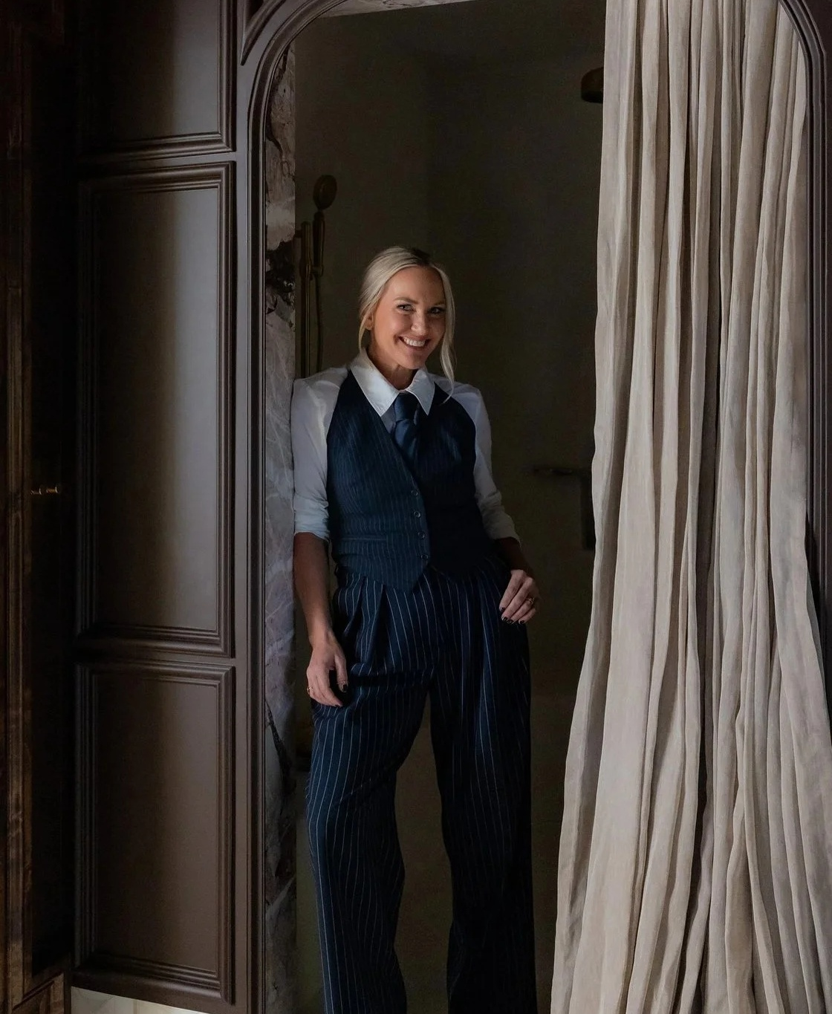  Ginger Curtis  Urbanology Designs | 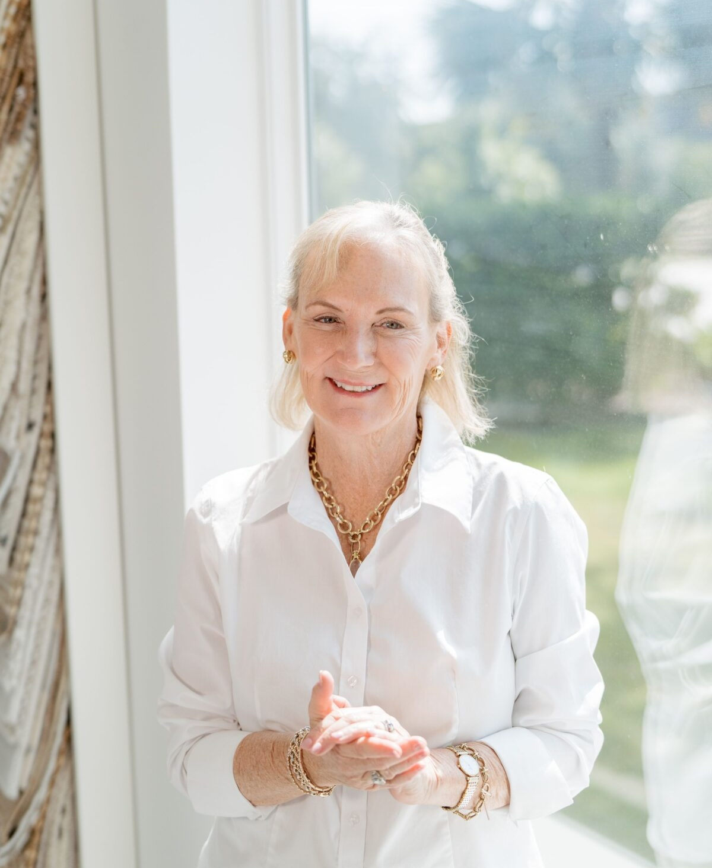  Margaret Donaldson  MDI Luxury Design Inc | 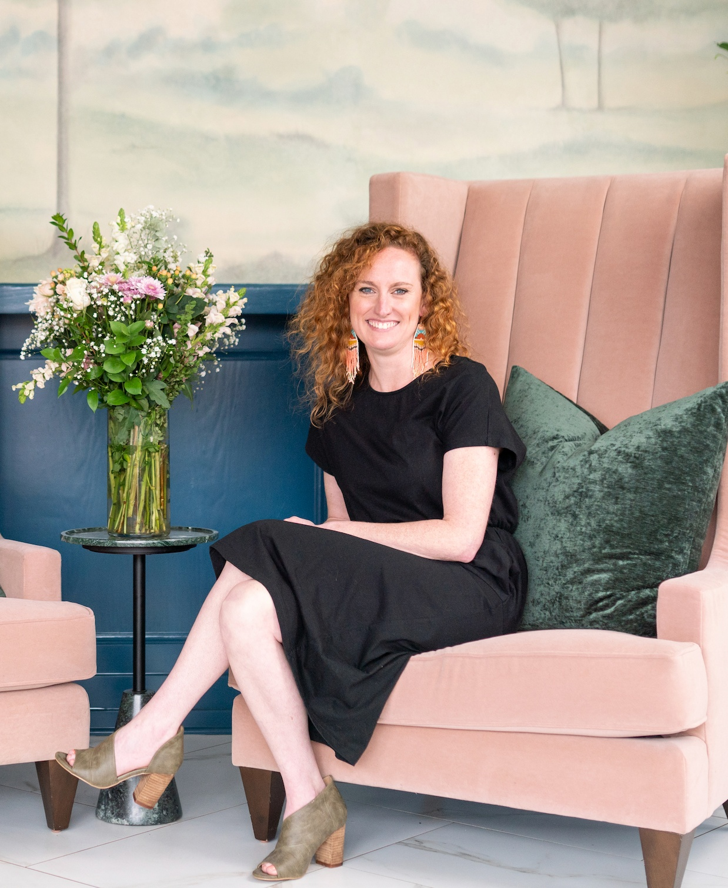  Catherine “Cat” French  Cat French Design
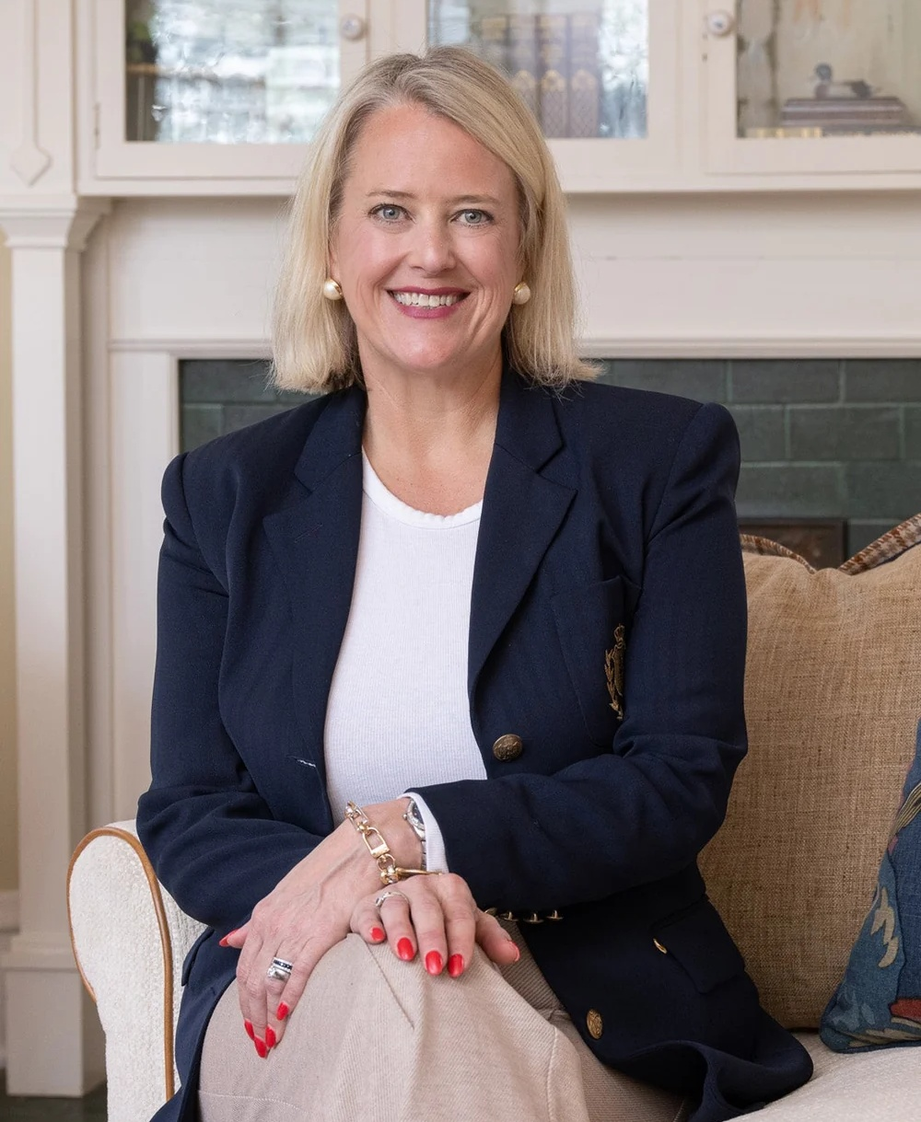  Carlie Goss  Nell Hills Design |   Gary Inman  Gary Inman Interiors |   Stephanie Kraus  Stephanie Kraus Designs
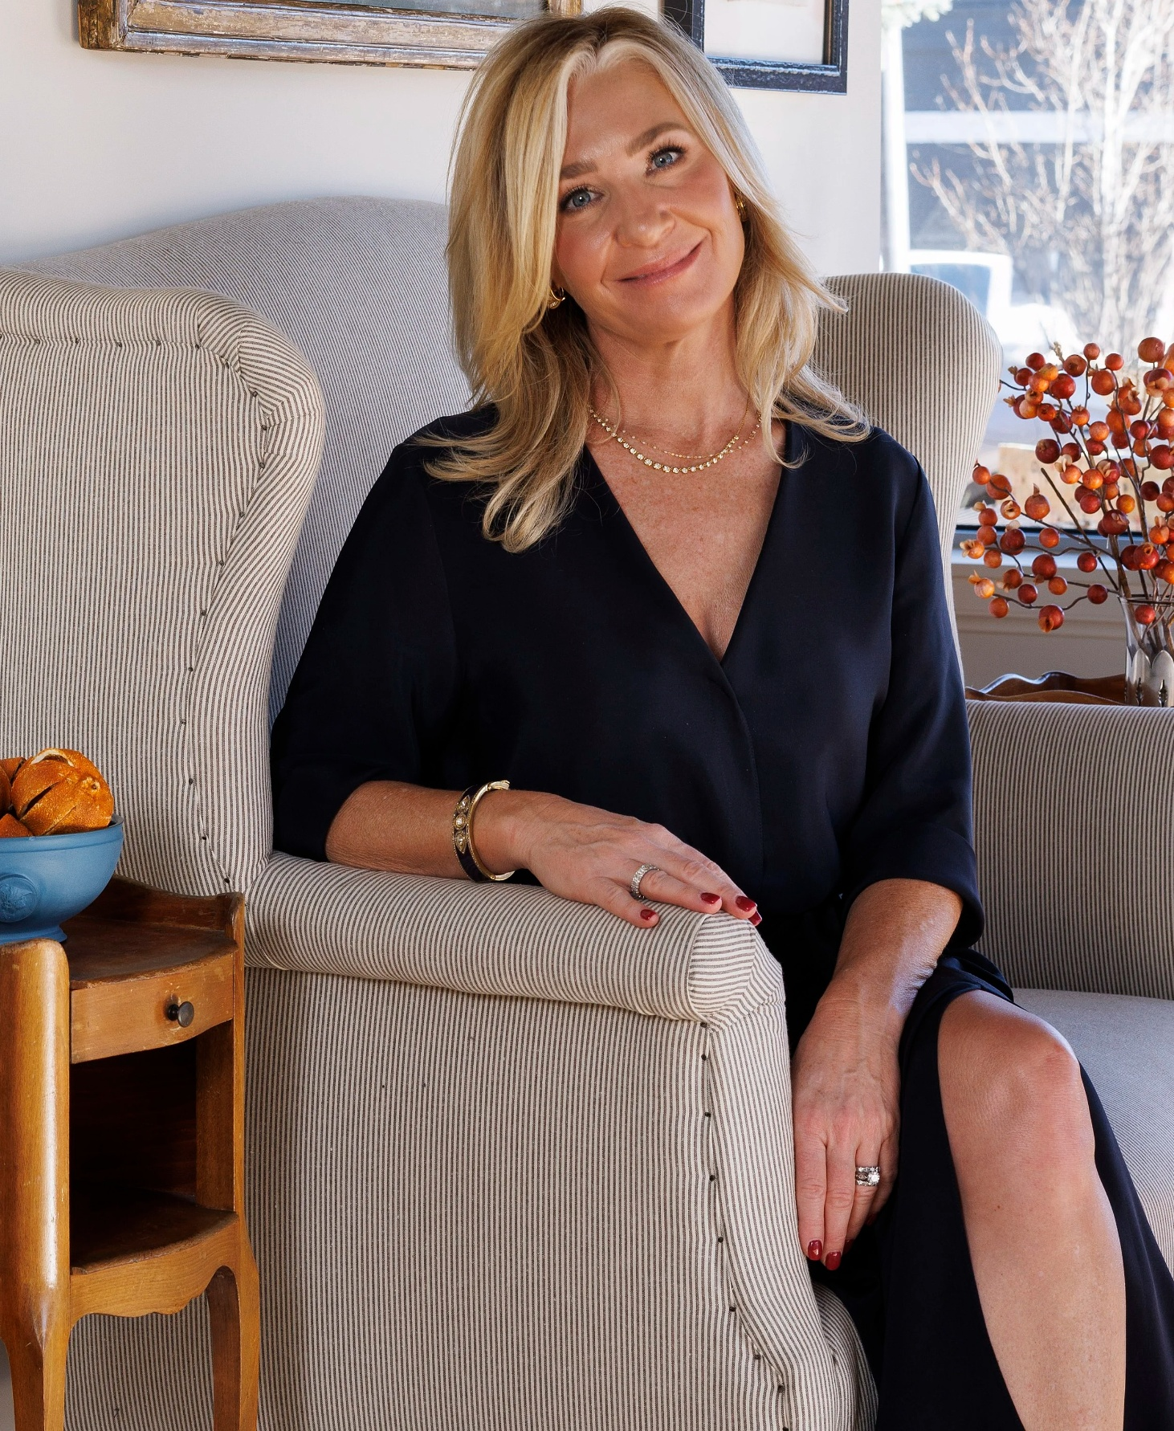  Martha “Marty” Lord  Martha Lord Interiors |   Lisa Mende  Lisa Mende Design |   Jamie Merida  Bountiful Home
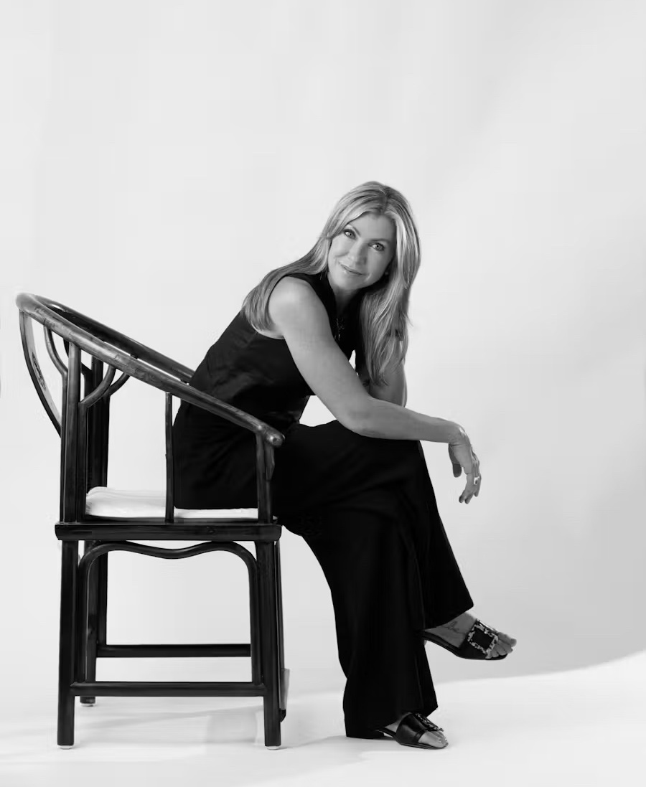  Leslie Schofield  Leslie Schofield Studio | 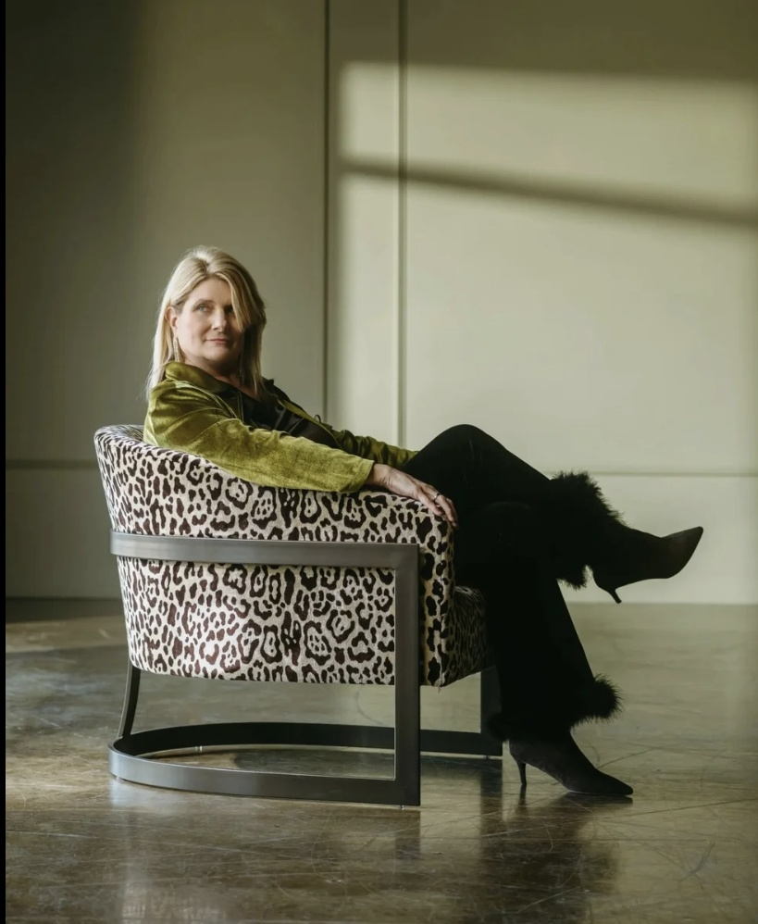  Denise Smith  The Home Studio Collective |   Courtney Thomas  Courtney Thomas Design
Sarreid’s High Point showroom is located in the C&D Building, 201 W. Commerce Ave., third floor, Space 3-D, High Point, North Carolina.
About Sarreid Ltd.
For nearly 60 years, Sarreid Ltd. has been creating heirloom-quality furniture that blends timeless craftsmanship with inspired design. From their home base in Wilson, North Carolina, and their showroom in High Point, they proudly serve designers and retailers around the world. Known for their signature Jupe dining tables — celebrated for their innovative engineering and classic style — as well as finely crafted casegoods, leather seating and accents, every Sarreid piece is built to be as enduring as it is beautiful. Learn more at www.sarreid.com.

Press Images Here

# # #
Media Contact
Dawn Brinson
A New Day Creative Communications & Marketing
Email: dawn@anewdaymktg.com

