Copeland Furniture Debuts the European-Inspired Whitney Bedroom Collection at Fall High Point Market
Vermont Manufacturer Pairs New Bedroom Introduction with Refreshed Brand Identity

High Point, NC (October 17, 2026) - At Fall 2026 High Point Market, Copeland Furniture introduces Whitney Bedroom, a European-inspired collection, paired with a continued brand refresh.
Whitney Bedroom: European Design, Modern Precision
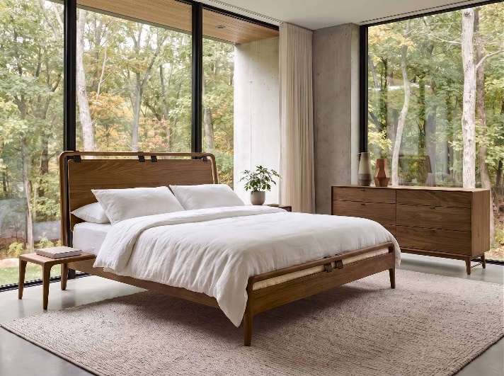
Whitney draws on the clean, contoured lines of European design and reinterprets them through Copeland’s high-tech manufacturing capabilities. With a continuous exterior headboard frame and leather straps joining an inset, solid wood panel, the bed is a direct nod to the Whitney Lounge Chair and Ottoman, introduced by Copeland at April market. Case goods feature a continuous frame and curved inset drawers that echo the headboard shape, paired with slim, angled stretcher-joined legs that give the collection a light, sculptural stance.
NEW: Whitney Bedroom Collection in Natural Walnut
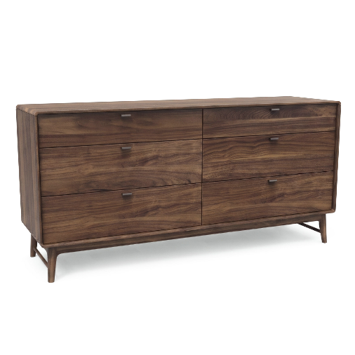
NEW: Whitney Six Drawer Dresser in Natural Walnut
“Whitney is the clearest expression yet of where Copeland is headed,” says Armin Driver, Design Director. “It’s a European silhouette at its heart, but every curve of the case frame and every angle in the stretcher legs is possible only because of how far we’ve pushed our manufacturing. It feels effortless because of the precision underneath.”
"The precision of the sculpted frame was the hardest part to get right," says product designer and engineer Jake Hanson. “We developed new ways to get complex angles and parts to meet smoothly in solid wood. Using the CNC machines to create unique joinery led to Whitney becoming one of our more technically ambitious groups.”
Whitney is available in solid cherry (natural, autumn, cognac, saddle, and smoke finishes) and solid walnut, all with GREENGUARD-certified low-emission finishes. The bed comes in queen and king sizes at a 12-inch platform height, with an optional attached nightstand. The collection includes one- and two-drawer nightstands plus chests and dressers from three- to ten-drawer configurations.
Brand Refresh Continues
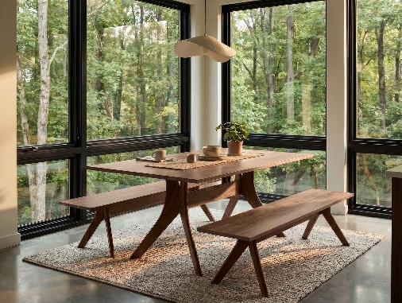
Copeland’s brand refresh, launched this spring with a refined logo and new website, advances this season with a warmer, more natural look across the website, photography, packaging, and market presence. The update emphasizes natural materials, softer styling, and the organic sensibility shared by collections like Whitney.
“Our first updates gave Copeland a clearer, more modern face,” says Ben Copeland, director of sales and marketing. “This phase is about warmth—the natural materials, honest craftsmanship, and Vermont roots at the center of what we do. We want the brand to feel as natural as the furniture itself.”
TOP SELLER: Audrey Dining Table and Bench in Natural Walnut
Copeland Furniture welcomes buyers and designers to experience the Whitney Bedroom collection firsthand at High Point Market, Showplace (Suite 5100, Floor 5), from October 17 to October 20, 2026. You can view Copeland Furniture’s current collections online at copelandfurniture.com.
About Copeland Furniture:
Copeland Furniture started in the 1970s as a family-owned and operated enterprise. Its mission is to create beautiful wood products from natural hardwoods while protecting the beauty of nature. During its many periods of growth, it has evolved from a one-man operation in an old garage in East Corinth, Vermont, to a state-of-the-art manufacturing facility located on the banks of the Connecticut River in Bradford, Vermont. More than five decades later, Copeland Furniture has stayed true to its creed and places high value on quality furniture that lasts multiple generations. It believes that understated, well-designed structures inform our creative sensibilities each day, and continuous improvement allows its company to thrive and excel. For more information, please visit the official website www.copelandfurniture.com.

